***RESUME***

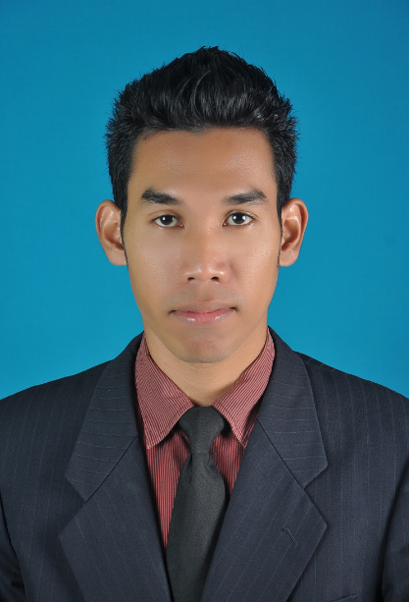

**Contact Info**

Address : Lot 893 Kg Pengkalan Nangka Pengkalan Chepa 16100 Kota Bharu, Kelantan

Mobile No : 014-5454068

Email : [nikmohamadharismurshidi@yahoo.com](mailto:nikmohamadharismurshidi@yahoo.com)

**Personal Particulars**

Name : Nik Mohamad Haris Murshidi Bin Nik Hassan

Age : 25 years

Date of birth : 21 Oct 1992

Nationally : Malaysia

Gender : Male

Marital status : Single

IC No : 921021-03-5509

Permanent Residence : Malaysia

**Education Background**

**Degree**

Field of Study : Engineering of Electronic (Electronic Communication)

Institute/University : University Teknologi MARA (Uitm) Shah Alam

CGPA : 3.29

**Diploma**

Field of Study : Engineering of Electrical (Electronic)

Institute/University : University Teknologi MARA (Uitm) Kampus Dungun

CGPA : 3.05

Graduation Date : March 2013

**SPM**

Field of Study : Engineering of Technology

Institute/University : SMK Pengkalan Chepa 2

Grade : 2(A), 3(B), 4(C), 2(D)

Graduation Date : December 2009

**Responsibility on job**

* To go above and beyond my current position
* Proving responsibility the tasks giving at work
* Responsibility in the workplaces
* Responsible to quantify and present my action results
* Always getting myself ready for urgent jobs

**Working Experience**

**Upskilling Programme 2016**

Position Title : Professional certification (AutoCAD 2015)

Position Level : Industrial Training (Contract 2 Months)

Duration : 3/1/2017 - Present

Salary : RM1000 per month

**Mat Sulaiman Trading (MST)**

Position Title : Practical Student

Position Level : Industrial Training (Contract 2 Months)

Duration : 28/6/2015 - 30/8/2015

Salary : RM15 per day

**Jabatan Pembangunan Wanita Negeri Kelantan (JPWNK)**

Position Title : Pekerja Sambilan Harian (PSH)

Position Level : Part-timer (Contract 3 Months)

Duration : 9/6/2013 - 8/9/2013

Salary : RM54 per day

**Macdonalds Midvalley**

Position Title : Crew

Position Level : Part-timer

Duration : 2 Months

Salary : RM5 per hour

**Skills**

**Skill Years Proficiency**

MS Office >5 Excellent

MS Power Point >5 Excellent

Photoshop CC 2015 >1 Good

AutoCAD (2015) >1 Good

Android Studio >1 intermediate

C++ >3 intermediate

Arduino >2 intermediate

PHP Files >1 intermediate

**Language**

**Language** **Spoken Written**

Bahasa Malaysia Excellent Excellent

English Good Good

**Activities**

* Final Year Project exhibition’s day
* Member of GEMA (Group of Entertainment of Muslim Art)
* Participant of Crazy English Competition 2011
* Member of Tutor Program Try To Excel Yourself
* Participant in Paintball Challenge 2.0 Tournament
* Participant in Malaysian Book of record on Fire Drill

**Additional Info**

* Full clean B2 and D driving licenses
* Can work under pressure and meet tight deadline
* Easy to adapt with new work environmental
* Optimist to improve work skills.
* Guided with the concepts of 5S Japanese and kaizen.

**Career Objective**

* To excel in my field through hard work, research, skills and perseverance. To serve my parents, and my country with the best of my abilities.
* To succeed in an environment of growth, excellence and earn a job which have provides me job that satisfaction, self-development, and help me achieve personal as well as organization goals.

**Reference**

The following people have agreed to provide any additional regarding my qualification and characteristic:

1. Dr. Azlina Idris

Employability Coordinatoor (Industrial Training)

Faculty of Electrical Engneering.

Universiti Teknologi Mara,

40450 Shah Alam, Selangor

Tel: +603-55436016